UNIVERSIDADE FEDERAL DE PARAÍBA

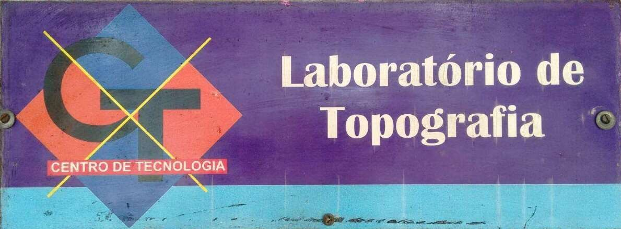

DECA - DEPARTAMENTO DE ENGENHARIA CIVIL E AMBIENTAL

CENTRO DE TECNOLOGIA - LABORATÓRIO DE TOPOGRAFIA – LABTOP SAÍDA DE EQUIPAMENTOS E TERMO DE RESPONSABILIDADE

Aula Prática

**PROFESSOR RESPONSÁVEL:**  **FINALIDADE:**  **DISCIPLINA:**   **CURSO:**   **DATA / HORA AULA:** / / - **HS**

**PREVISÃO DE CHEGADA / HORA: / / - HS**

|  |  |  |
| --- | --- | --- |
| **INSTRUMENTOS** | | |
|  | **PATRIMÔNIO** | **OBSERVAÇÃO** |
| **TEODOLITO / ESTAÇÃO TOTAL** | **/** |  |
| **NÍVEL DE LUNETA** |  |  |
| **GNSS** |  |  |
| **BÚSSOLA** |  |  |
| **ACESSÓRIOS** | | |
| **TRIPÉ** |  |  |
| **MIRA-FALANTE** |  |  |
| **BALIZA** |  |  |

**OUTROS ACESSÓRIOS / INSTRUMENTO:**



**RESPONSÁVEIS PELO MANUSEIO DOS EQUIPAMENTOS**

**ALUNOS / GRUPO:**

**AMARELO** **AZUL** **BRANCO** VERDE VERMELHO PRETO ROSA

**1 -**

**2 -**

**3 -**

**4 -**

**5 -**

**6 -**

**MAT / IDENT. MAT / IDENT. MAT / IDENT.________________________________**

**MAT / IDENT. MAT / IDENT. MAT / IDENT.**

**OBS.:_____________________________________________________________________________________________________________________________________________________________________________________________________________________________________________________________________________________________________________________________________________________________________________________________________________________________________________________________________________________________________________________________________________________________________________________**

